**Student Guide**

**(Shake phone on the splash screen for a surprise 😉)**

**Description-**

Student Guide made for Heriot-Watt Students provides its users with ease of access to many features.

**App Sections-**

* Main Screen- Gives access to all the features built in the app.
* Campus Overview- Provides Information and location of HW Campuses Located Around the world.
* Notes- Allows users to write and store notes without exiting the application also giving a date and time stamp showing when the specific note was written.
* Weather- Shows the weather of the location user is in
* Emergency Services- If needed has quick access to Emergency Services
* Places to visit- Shows users ‘Hotspots’ in the country which are famous and a must visit.
* Assistive touch- to make it much easier to switch between screens in the app.

Student Guide has all the necessities needed by an ideal student.

Made Using MIT App Inventor 2



**Functionality-**

This App in its current state has many functionalities.

With many of the blocks being interconnected with each other such as the campus detail selection block which provides details of heriot watt campuses around the world depending on which campus location selected. This method enables users to check details for all HW campuses.

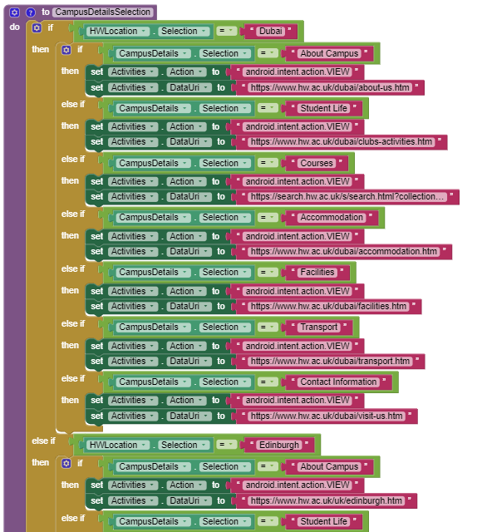

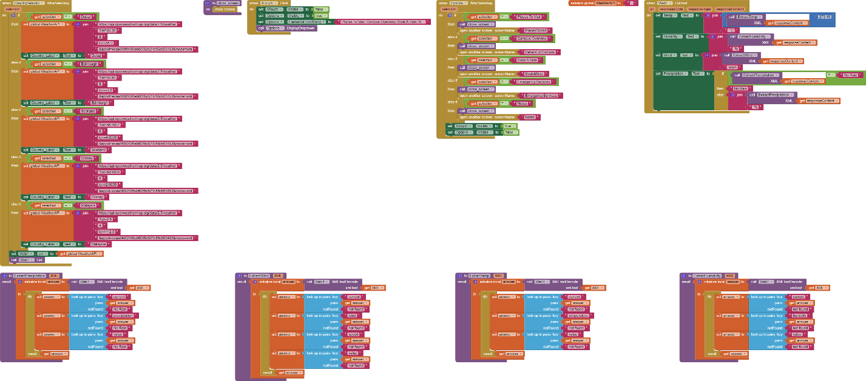

Even the weather function in the app provides the weather forecast of the country chosen from the campus locations. This method provided easier means of providing information to the users of different weather patterns

Most of the components used in the app were Labels, Textboxes, Layout Arrangements, Buttons, Notifiers, Activity Starters etc.

**Reflection-**

This App was originally going to be an app providing users with information about the campus and a notepad but with the reviews given to me by my peers and teacher motivated me to include many more features into the app and making it an ideal app for students

My idea for CW2 was to make the app more accessible and easier to use with adding the assistive touch feature and making it so there is information and weather details for each HW Campus locations.

Many of my peers had told me that the app was a bit buggy and ran slow because of the number of screens I was using for my app this led me to the idea of closing all screens and adding assistive touch to re-open the screens. The feedback given to me by the teacher told me to make certain components of my app easier to use and provide some instructions on how to use certain parts of my app. Which I did and also added a set of instructions on parts of app which might seem difficult to use.

Overall this app should provide students all the information they would need for different HW campuses and make their search easier.